Bosch Training and Live Demonstration
Come find out how Bosch’s 20 SEER, true variable speed, 85 stage/speed compressor, can be matched up with anybody’s thermostat, air handler, furnace and evaporator coil by using robust, Non-Communicating technology. Also, find out how Bosch adds value for your customers and can help you win more bids with lower estimates.
- 10 Year warranty right out of the box, 30-day labor warranty
- Load Matching Technology
- Air Conditioning with Heat Pump capability (Either AC or HP)
- Easy 2 wire AC or 4 Wire Heat Pump Installation
- Cools to 15F outside and Heats to -5F
- Self-Diagnosing with built in system protections
- Parameter checks allow you to see pressures, temperatures, target temperatures, amps, voltages without using gauges or a meter
- Wi-Fi capability coming by the end of the year
- 10 Speed condenser fan motor
- Accredited Bosch Contractor (ABC) Dealer - FREE
  - Get an additional 1-year warranty and 90-day labor warranty with registration
  - Put on Bosch’s Contractor Locator Page
  - Earn points towards rewards
  - Continuing training
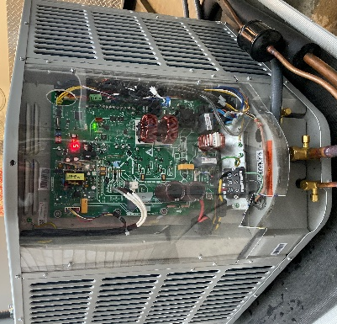

*You can also call me for more information on our Bosch Units at the number below

